**Use your opportunity to visit our country.**

Travel guide around Russian cities.

Millions of people all over the world are fond of travelling. They travel to see other countries and continents, to discover different ways of life, to meet different people and to practice foreign languages. It goes without saying that travelling broadens the mind. While travelling we can see and learn a lot of things that we can never learn staying at home and watching TV or reading books. That's why a lot of foreign people come to Russia to get acquainted with Russian culture, with Russian customs and traditions.

Moreover, Russian megapolises give you’re an opportunity to use convenience transport system. Variety of shops and cafes on all tastes.

There are five the biggest cities in our country you can visit with pleasure.

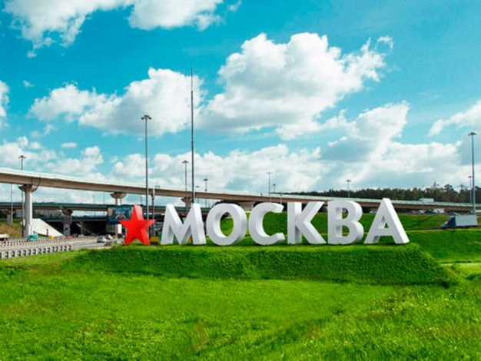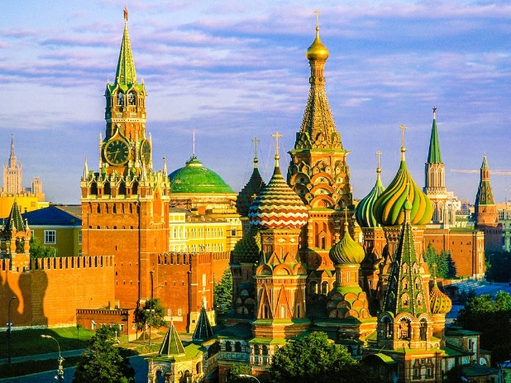

**Moscow** isn't the only large city that's found in Russia.Moscow is the most populous Russian city with over 11.5 million residents.

It’s likely that the first place you visit coming to Moscow will be the Red Square. Frankly speaking, only tourists usually walk on it. Muscovites are seen here much less often. The square has important historical meaning. Right here there is the frontal place where tsar decrees were read from. Also, pay attention to the amount of sightseeing situated near the square. Red Square is near the Kremlin. The first Kremlin was built in 1368. It was made of white stone. And that is why Moscow was called 'white-stoned' in the past.

Furthermore, in Russian capital you’ll find lots of cathedrals, museums, monuments. It’s not likely that one visits to Moscow is enough to see even a half of its sights.

**Saint Petersburg**

Saint Petersburg is the second biggest Russian city with over 4.88 million residents. 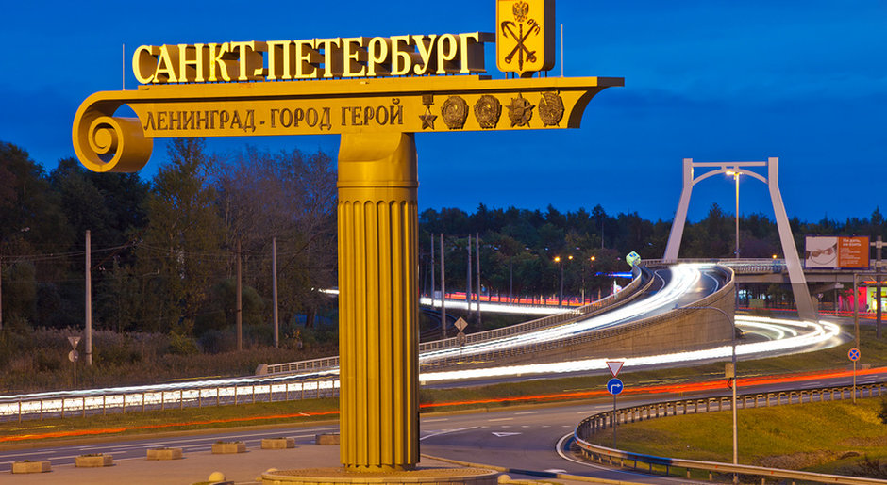

In the cultural capital Saint-Petersburg you’ll find a lot of museums, monuments and cathedrals. The most famous museum of world importance is of course the Hermitage. The works of arts collection of the Hermitage was started with Ekaterina’s (Cathrine) purchase of 225 pictures made by masters from Western Europe. Today the museum has about three million exhibits. Just imagine! You’ll need 15 years to see all the exhibits of the Hermitage having a minute looking at each of them and spending 8 hours a day on that. Besides each hall itself is a work of art. Malachite, George and Peter halls are very popular among tourists.

**Novosibirsk.** Novosibirsk is the most highly populated city is Asian Russia with over 1.47 million residents.

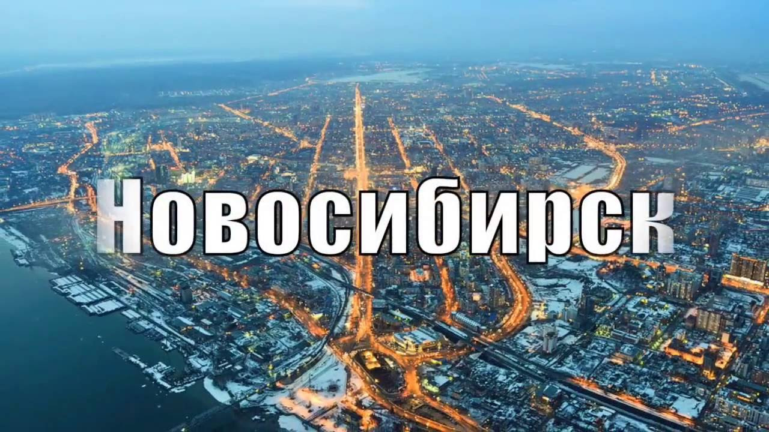

Novosibirsk is the third largest city in Russia. It is situated in the South-West of Siberia. If you want to find it on the map, you have to look at the crossing of the following borders: Kazakhstan, Mongolia and China. Novosibirsk is often called the Capital of Siberia.

Among the chief attractions of the city and town are various museums, including the Geology Museum with its collection of precious stones and gems. There is a good picture gallery with a permanent exhibition of the artworks by Nikolai and Stanislaus Rerich, as well as several exhibitions which are renewed and changed regularly. The vast city Zoo receives many visitors through the summer. Adults and children alike enjoy meeting various exotic animals, and playing among the dinosaur replicas. The City Day is celebrated every year, with lots of festivities everywhere.

**Yekaterinburg.** Yekaterinburg is the fourth largest city in Russia and the capital of the Ural region. The city was founded by the first Russian Emperor, and marks the place where the last Russian Emperor and his 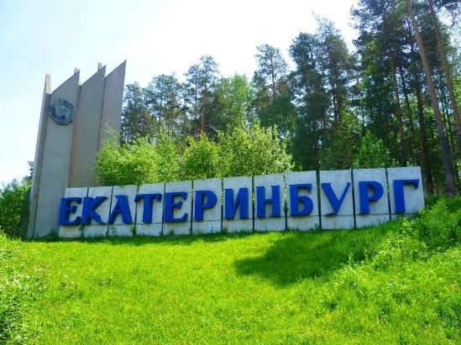family were assassinated.

**Yekaterinburg** was named after Russian emperor Peter the Great's wife, Yekaterina, who later became Catherine I after Peter's death. Today, some of the tallest skyscrapers in Russia can be found here. But most tourists head for the old centre with its impressive historic buildings, including the Church on Blood, one of Russia's largest churches. It stands on the spot where members of the Russian Imperial family were shot by the Bolsheviks in July 1918. And believe it or not, there’s also a monument to the Beatles nearby!

**Nizhny Novgorod.**

Nizhny Novgorod is the capital of Nizhny Novgorod Oblast and Volga Federal District. The city was previously referred to as Gorky (1932-1990) after Gorky Maxim, a known writer who was born in the region. The city served as a great trading center for the Russian Empire in 1817.

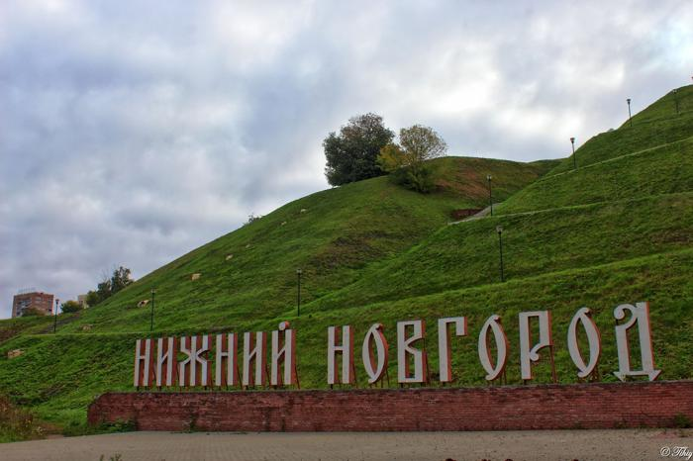 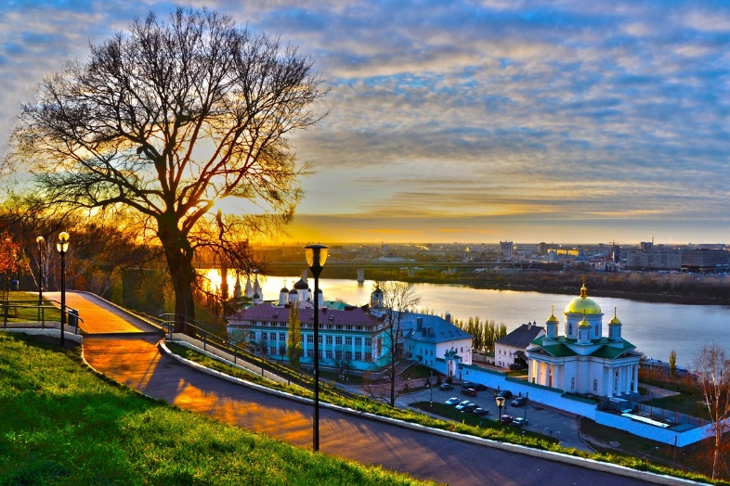

It is beautifully located on a number of hills, called the Dyatlov Hills in the name of the brigand, nicknamed Dyatel, who dominated the place in those days. The location offers a marvelous view from the river, which was noted in the past by high-ranking Russian and foreign guests, tsars, emperors, and also writers, historians and travellers. Actually, it is situated on 2 rivers – the Volga and the Oka. Its location is unique in that you can’t find anywhere else in Europe or in the world another city so highly placed at the confluence of two large rivers. It’s a pleasure to walk along the ancient Kremlin walls or along the embankments. In fact, these are my favourite walking routes. People with extrasensory abilities say that a walk along the Upper Volga embankment has a healing effect on the mind as well as on the body.